Задание 1:

1) создать сервис, состоящий из 2 различных контейнеров: 1 - веб, 2 - БД

2) далее необходимо создать 3 сервиса в каждом окружении (dev, prod, lab)

3) по итогу на каждой ноде должно быть по 2 работающих контейнера

4) выводы зафиксировать

1. Создадим сервис

petr@petr82:~/dockerLessons/home-work-5$ nano docker-compose.yml

petr@petr82:~/dockerLessons/home-work-5$ cat docker-compose.yml

version: '3.9'

services:

db:

image: mariadb:10.10.2

restart: always

environment:

MYSQL_ROOT_PASSWORD: 12345

adminer:

image: adminer:4.8.1

restart: always

ports:

- 6080:8080

petr@petr82:~/dockerLessons/home-work-5$

petr@petr82:~/dockerLessons/home-work-5$ docker compose up -d

[+] Running 3/3

✔ Network home-work-5_default Created 0.2s

✔ Container home-work-5-db-1 Started 0.4s

✔ Container home-work-5-adminer-1 Started 0.3s

petr@petr82:~/dockerLessons/home-work-5$ docker compose ps

NAME IMAGE COMMAND SERVICE CREATED STATUS PORTS

home-work-5-adminer-1 adminer:4.8.1 "entrypoint.sh php -S [::]:8080 -t /var/www/html" adminer 27 seconds ago Up 25 seconds 0.0.0.0:6080->8080/tcp, :::6080->8080/tcp

home-work-5-db-1 mariadb:10.10.2 "docker-entrypoint.sh mariadbd" db 27 seconds ago Up 25 seconds 3306/tcp

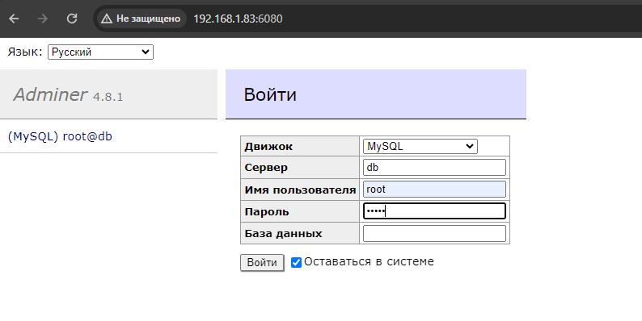

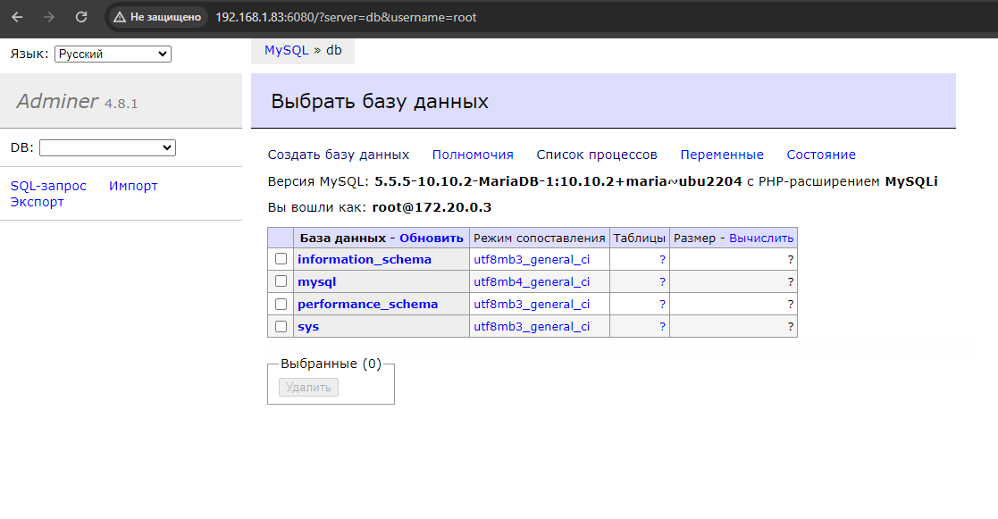

petr@petr82:~/dockerLessons/home-work-5$ docker compose down

[+] Running 3/3

✔ Container home-work-5-adminer-1 Removed 0.5s

✔ Container home-work-5-db-1 Removed 0.8s

✔ Network home-work-5_default Removed 0.3s

petr@petr82:~/dockerLessons/home-work-5$ docker compose ps -a

NAME IMAGE COMMAND SERVICE CREATED STATUS PORTS

1. Создадим 3 сервиса

